CURRICULUM VITAE

syamprakash j s
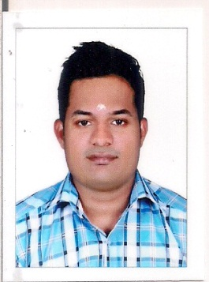

SAKUNTHALA MANDIRAM AMMACHANMUKKU ,

KOOTTIKADA P.O

kollam, KERALA

PIN: 691021

MOBILE : +919544717701, +917994347957
EMAIL : syamspjs1@gmail.com
CAREER OBJECTIVE

To be a part of this industry where my experience can be unshed to improve work in a challenging atmosphere by exhibiting my skills with utmost sincerity & dedicated smart work for the growth of your esteemed organization along with mine

PROFESSIONAL EXPERIENCE

- I AM FRESHER

PROFESSIONAL QUALIFICATION

Diploma in Hospitality Travel and Customer Service at
Frankfinn Institute of Air Hostess TrainingCenter, Kollam, Kerala
Certificate from ICM – UK
DATA ENTRY IN ICDC THIRUVANANTHAPURAM

EDUCATIONAL QUALIFICATION

 | Name of the institution | Year of pass
Plus Two | VALATHUNGAL VHSE KOLLAM | 2012
SSLC | MAYYANAD HSS KOLLAM | 2010

LANGUAGES KNOWN

 | Read | Write | Speak
Malayalam
English
Hindi

PERSONAL PROFILE

Name : Syamprakash J S
Father’s Name : Jayaprakash
Age & : 23
Date of birth : 10 / 05 / 1993
Marital status : Single
Religion & Caste : Hindu, Ezhava
Sex : Male
Height : 168
Weight : 74
Nationality : Indian
Permanent Address : SAKUNTHALA MANDIRAM
AMMACHANMUKKU
KOOTTIKADA P.O
KOLLAM (DISTRICT)

COMPUTER KNOWLEDGE

- Data-Entry
- Microsoft office
- Internet
- Fidelio CRS
- Galileo GDS
- Power point
- Photoshop

STREGTH

- punchuality
- Positive attitude
- Self confidence
- Communication
- Leadership skill

HOBBIES

- Travelling
- Cooking
- Cinema

REFERENCE

1) Gibu Gabriel
Training faculty Frankfinn Institute of Airhostess
Training, Kollam, Kerala
Mobile : 9947693067

2) Adv.Vijay(EKM)
Mobile : 09567870163

DECLARATION

I hereby declare that the above information’s given by me are true and correct to the best of my knowledge and belief.

Place :Mayyanad
Date : 16-03-2017
SYAM PRAKASH J S

